Probability Distributions
Before probability distribution is defined formally, the definition of a variable is reviewed. In Chapter 1, a variable was defined as a characteristic or attribute that can assume different values. Various letters of the alphabet, such as X, Y, or Z, are used to represent variables. Since the variables in this chapter are associated with probability, they are called random variables.
For example, if a die is rolled, a letter such as X can be used to represent the outcomes. Then the value that X can assume is 1, 2, 3, 4, 5, or 6, corresponding to the outcomes of rolling a single die.

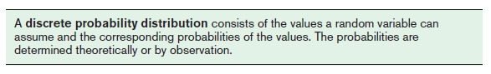
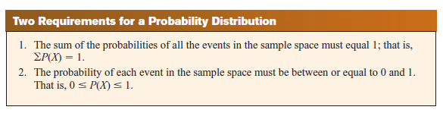
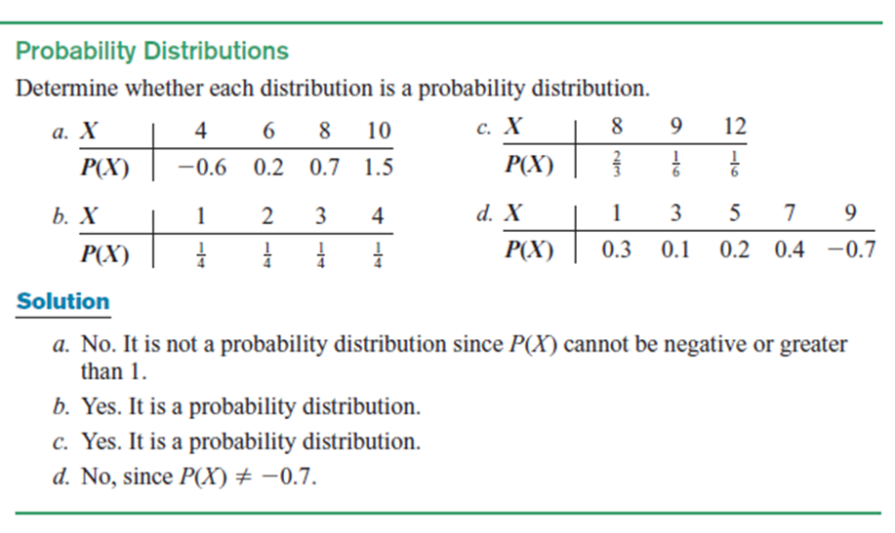

Practice Questions
For Exercises 6 through 11, determine whether the distribution represents a probability distribution. If it does not, state why
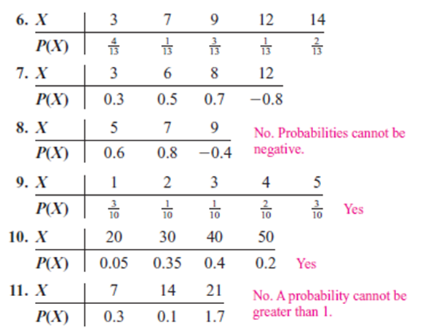

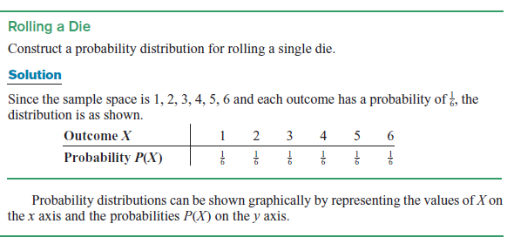
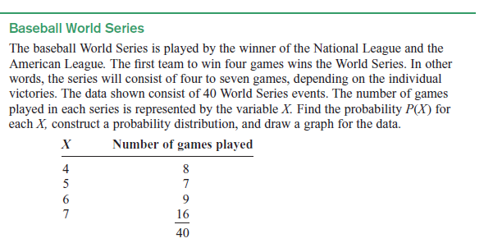
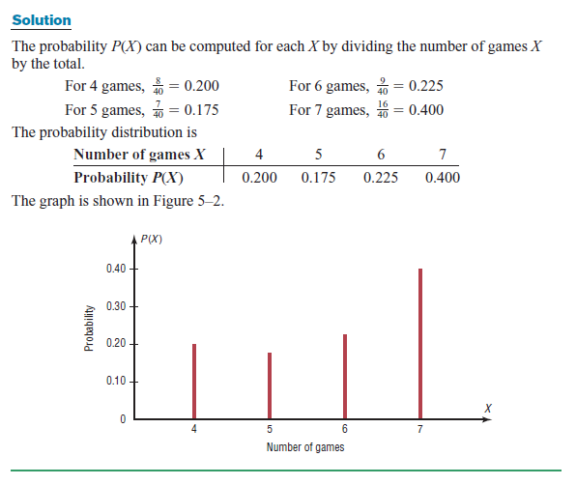

Practice Questions
Construct a probability distribution for the data and draw a graph for the distribution.
1.Server Load Balancing
The probabilities that a newly arrived request will be routed to server A, server B, or server C are 2/5​, 1/5​, and 2/5​, respectively.
2.Number of Network Packets Dropped
The probabilities that a network router will drop 0, 1, or 2 packets during a particular time interval are 0.7, 0.2, and 0.1, respectively.
3.Number of Failed Login Attempts
The probabilities that a user will have 0, 1, 2, or 3 failed login attempts before successfully logging in are 0.5, 0.3, 0.15, and 0.05, respectively.
Mean, Variance, Standard Deviation, and Expectation
The mean, variance, and standard deviation for a probability distribution are computed differently from the mean, variance, and standard deviation for samples. This section explains how these measures—as well as a new measure called the expectation—are calculated for probability distributions.
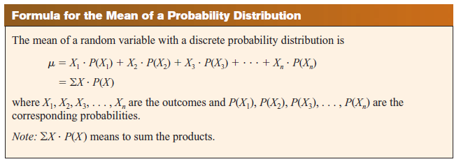

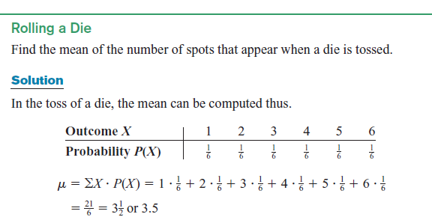
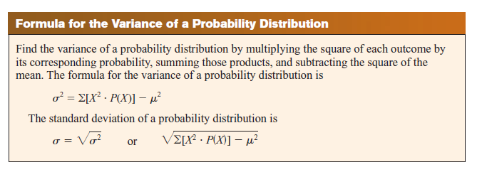
Note: Remember that the variance and standard deviation cannot be negative.

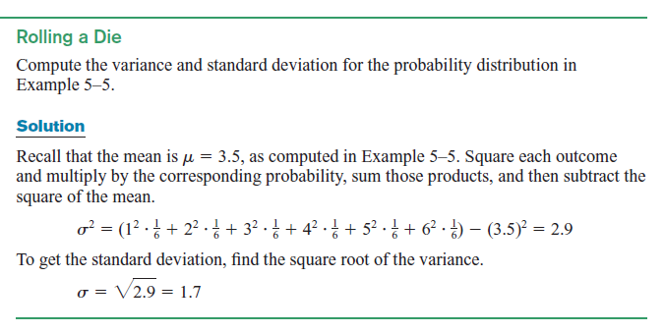

Practice Questions

1.Defective DVDs From past experience, a company found that in cartons of DVDs, 90% contain no defective DVDs, 5% contain one defective DVD, 3% contain two defective DVDs, and 2% contain three defective DVDs. Find the mean, variance, and standard deviation for the number of defective DVDs.

2.Suit Sales The number of suits sold per day at a retail store is shown in the table, with the corresponding probabilities. Find the mean, variance, and standard deviation of the distribution.
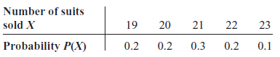
3.Number of Bugs Found in a Code Module
The probabilities that a newly developed code module will contain 0, 1, or 2 critical bugs in its initial testing phase are 7/10​, 2/10​, and 1/10​, respectively. Find the mean, variance, and standard deviation for the number of Bugs Found in a Code Module.

The Binomial Distribution
Many types of probability problems have only two outcomes or can be reduced to two outcomes. For example, when a coin is tossed, it can land heads or tails. When a baby is born, it will be either male or female. In a basketball game, a team either wins or loses. A true/false item can be answered in only two ways, true or false. Other situations can be reduced to two outcomes. For example, a medical treatment can be classified as effective or ineffective, depending on the results. A person can be classified as having normal or abnormal blood pressure, depending on the measure of the blood pressure gauge. A multiple-choice question, even though there are four or five answer choices, can be classified as correct or incorrect. Situations like these are called binomial experiments.
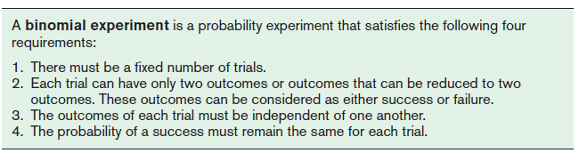
A binomial experiment and its results give rise to a special probability distribution called the binomial distribution.
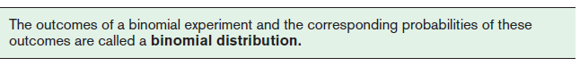
The probability of a success in a binomial experiment can be computed with this formula.

Binomial Probability Mass Function
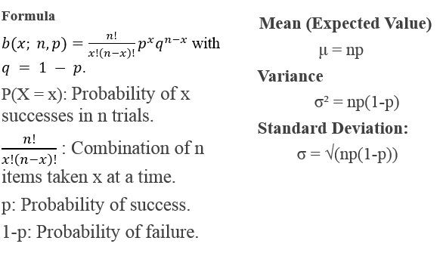
Example
A study found that 20% of software developers use a specific niche programming language for their personal projects. If a random sample of four software developers is selected, find these probabilities:
- Exactly 1 developer will use the niche language.
- At most 2 developers will use the niche language.
- At least 1 developer will use the niche language.
- d. Fewer than 2 developers will use the niche language.
Solution
Here, n=4 (number of trials) and p=0.20 (probability of success, i.e., a developer using the niche language). X∼B(4,0.20).

a. Exactly 1 developer will use the niche language.
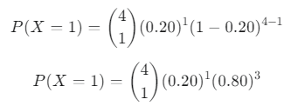
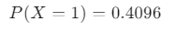
So, the probability that exactly 1 developer will use the niche language is 0.4096​
b. At most 2 developers will use the niche language.
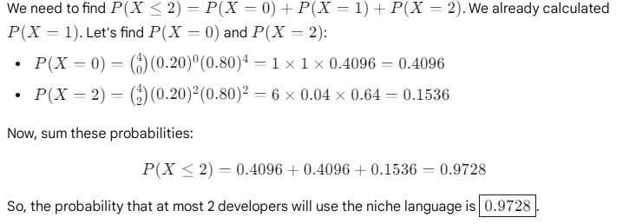
c. At least 1 developer will use the niche language.
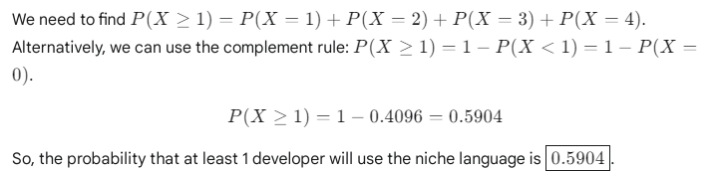

- Fewer than 2 developers will use the niche language.
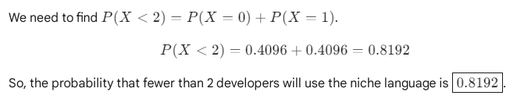
Practice Questions
Question 1
It is reported that 65% of software repositories on a popular platform use a specific open-source license. Choose 6 software repositories at random. Find the probability that:
- All use the specific open-source license.
- b. More than one-half use the specific open-source license.
- c. Exactly 3 use the specific open-source license.
Question 2
The percentage of software development teams that utilize agile methodologies is 75%. Choose 4 software development teams at random. Find the probability that:
a. None of the teams utilize agile methodologies.
b. More than 3 of the teams utilize agile methodologies.
c. Fewer than 2 of the teams utilize agile methodologies.
d. Fewer than 3 people will agree with that statement.
Mean,Variance and standard deviation

Question 1
If 80% of the applicants are able to pass a driver’s proficiency road test, find the mean, variance, and standard deviation of the number of people who pass the test in a sample of 300
Question 2
A large software company has 250 servers. Historically, there is a 0.5% chance that any given server will experience a critical failure during a typical week. Find the mean, variance, and standard deviation of the number of servers that will experience a critical failure in a week.

